Alejandra Celedon F.

Architectural Association

**Juan Martinez (1901-1971)**

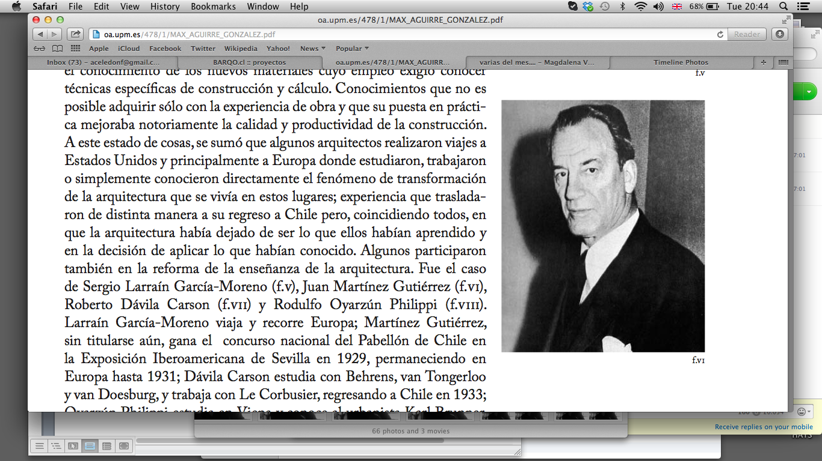

Figure 1: Juan Martinez

*Aguirre, M. (2004) PhD Thesis. La Arquitectura Moderna en Chile. Escuela Politécnica de Madrid, p16.*

Juan Martinez Gutierrez arrived to Chile with his family from Spain in 1909. He studied Architecture (1918) at the University of Chile, and trained in parallel in the Faculty of Arts. His professional life was always tied to this institution, first as Professor, then as Director of the School, and eventually as Dean of the Faculty of Architecture. There, he run and participated in two reforms to the teaching of the discipline, in 1933 and 1946 respectively. In a three-years visit to Europe (1928-31) he absorbs the work of renowned architects of the time, such as van der Rohe, Behrens, Le Corbusier and Gropius, what influenced his own architectural production, and by means of it, the Chilean architectural scene.

The core of his design work developed between the thirties and the fifties, consisting in a large number of public buildings, which stand for the construction of the identity of the emergent modern republic. Many of his buildings are related to education and culture, especially by way of liberal institutions such as the University of Chile.Although slightly neoclassical in appearance, his architecture represents a transition between traditional values and the embracement of modern ones: the blunt aesthetic in the use of concrete, the functional values and the image of monumentality has proved to be enduring. One of his first commissions was the adjudication of a public competition in 1927. The assignment was the construction of the Chilean Pavilion for the Iberoamerican Exhibition to be held in Seville, Spain. The avant-garde proposal was erected in 1929 and attempted to present an image of the country as ‘civilized.’ In opposition to the other (rather historicist) entries, Martinez employed the metaphor of Los Andes Mountain Range to distance the tropical image of Latin America for one based on the geographical determinism of the country. [1] This pursuit for a Chilean modern identity accompanied his later works.

The Faculty of Law of the University of Chile (1934-38) is one of the most recognized of his works, located in the city centre of the city of Santiago between the Mapocho River and San Cristobal Hill. The building, while carefully considered its privileged situation and local conditions, revised and revived traditional archetypical forms, such as the colonnade-facade, and the double-high access hall, but by means of a formal simplicity and lack of decoration representative of all his oeuvre. In 1943 he designed the Military School located in Las Condes, Santiago, which was the first building constructed in Chile with exposed concrete. He is later commissioned with the reconstruction of the Faculty of Medicine of the University of Chile, located in Independencia, Santiago, constructed between 1952 and 1960.[2] The building became the place to test the recent academic reform of the Faculty of Architecture in a real problem. It rationally solved a highly complex programme including the internal connection with the Hospital ‘José Joaquín Aguirre,’ setting forth the idea of a future Campus. Pioneer in the use of concrete is also the Church ‘Templo Votivo de Maipu,’ inaugurated in 1974, and commissioned through an international competition. The project is a monumental complex of ninety-meters-high that impacts in the skyline of the city with the sculptural forms.

Martinez’ emblematic buildings, spread along different districts of the capital, are today recognized landmarks, compulsory referents of the architecture of the city, and symbols of the construction of the modern republic in the first half of the twentieth century. His oeuvre belongs to a series of works, which represents a tension between tradition and modernity, a duality in the architectural thinking of the first half of the century in Chile.

He is appointed president of the Chilean School of Architects in 1952, and became the first architect to be awarded with the Architectural National Award in 1969. The architect and painter died two years later.

**List of works**

1929 Chilean Pavilion for the Iberoamerican Exhibition

1938 Faculty of Law University of Chile

1943 Military School

1960 Faculty of Medicine University of Chile

1974 Templo Votivo de Maipú - Church

**References and further reading**

1. Aguirre, M. (2004) PhD Thesis. La Arquitectura Moderna en Chile. El cambio de la arquitectura en la mitad del siglo XX. El rol de la organización gremial de los arquitectos (1907-1942) y el papel de las revistas de arquitectura (1913-1941). Escuela Politécnica de Madrid.

2. Basáez, Patricio (1999) 150 Años de la Enseñanza de la Arquitectura en la Universidad de Chile. Santiago de Chile: Ediciones de la Universidad de Chile, Santiago. ISBN 9561903113.

3. Cheyre, C. (2013) Obra gruesa. De la Fuente Editores, Santiago.

4. Strabucchi, W. Torrent, H. (1996) La arquitectura chilena en cambio entre las décadas 40 y 50: superficie y fondo de la arquitectura como representación : ausencias, presencias y ambigüedades. Seminario No 5. Pontificia Universidad Católica de Chile, Escuela de Arquitectura, Santiago.

5. Muñoz, D. (1987) Premios Nacionales de Arquitectura 1969 – 1985. Universidad del Biobío Facultad de Arquitectura y Construcción. Concepción.

**Visual Material**

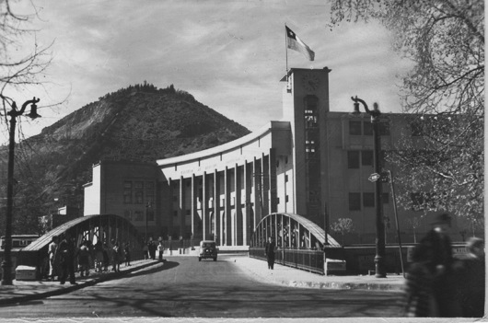

Figure 2: Faculty of Law University of Chile. 1938, Archivo del Instituto de Historia y Patrimonio de la FAU y al Archivo Personal del Profesor de la FAU, Ignacio Salinas .

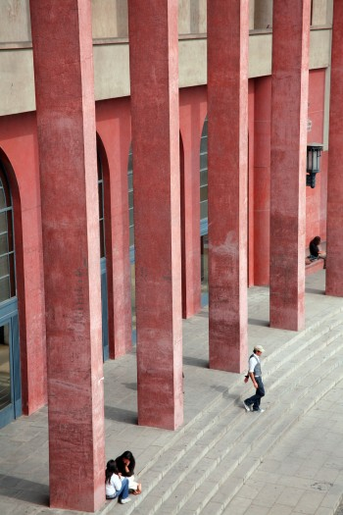 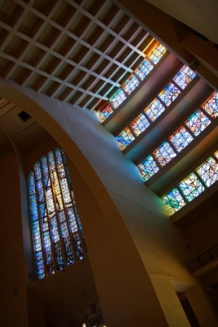

Figure 4: (left) Faculty of Law University of Chile. 1938. Cortesía de Chilearq. (right) Templo Votivo de Maipú. 1943. Sistema de Difusión Arq. Chilena PUC.

1. For an expantion of this argument see Dümmer, S. (2009) Metáforas de un país frío. Chile en la Exposición Iberoamericana de Sevilla en 1929. Artelogie : Recherches sur les arts, le patrimoine et la littérature de l’Amérique Latine, Vol 3.
2. CA Oficcial Magazine of National School of Architects.1950 Escuela de Medicina. No 43. Santiago, Chile. 1968. p. 26-28

   Auca Magazine - Santiago, Chile. C.2, No 35, Santiago, Chile. 1978.